Advantages of CAN Bus:
- Multiple use of signals
- Reduction of cost, weight and installation space
- Improved reliability, security and maintainability
- Easy connection of other system components
- Simplification of the vehicle assembly

Other Bus Systems:
- LIN (Class A) (Data Rate < 10Kbit/s): Used in Sensor-Actuator Networking.
- FlexRay and TT-CAN (Class C+) (Data Rate < 10 Mbit/s): Used in Networking in the drive and chassis (By-Wire).
- MOST (Class D) (> 10 Mbit/s): Used in Networking in Telematics and Multimedia.

CAN Bus Structure:
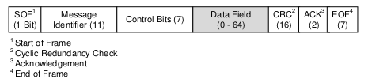

- Control Bits specify if the message is remote frame and how long the real payload is.
- After that, the Data Field follows a CRC-checksum, which checks the data for errors.
- After EOF, there must be at least 3 bits, which are called inter-frame-space, before the next frame can be transmitted.

CSMA/CS Principle:
Since all the participants who want to send a message listen to the bus and wait until the bus is free, the CSMA/CS principle is used and consists of avoiding and solving collisions through an arbitration phase, where the message identifier and the two states of the bus (recessive and dominant) are used. At first, the bus is in an idle state which is the recessive state. Dominant level bits („0“) always overwrite recessive level bits („1“), thus if participant A tries to send a dominant bit („0“) and another participant B tries to send a recessive bit („1“), the bus will favour the dominant level and hence allowing participant A to have the exclusive access of the Bus.

Masking:
